Welcome to the 2017 HJJ Spring Fling!!!!

Acting Regional Director will be Margi Baldwin Moore.

Racing Format
This will be a one ring tournament. Warm ups will be 2 minutes throughout the weekend to allow spacing between races; however, we reserve the right to shorten warm-ups to 90 seconds should we fall too far behind schedule. Please note that with only 20 teams, please be patient as dogs are being switched.

Tournament Scoring Format: All divisions racing a round robin format will earn one tournament point for each heat one, and two tournament points for winning the race. No tournament points will be given for tied heats. One tournament point will be given to each team for tied races. Tournament placements are determined by adding up all accumulated points.

Tie Breakers:
1. Fastest time head to head
2. Fastest time in division (including combined divisions if applicable)
3. Tie-breaker race 2 of 3 heats
Venue Information
The building will be open until 9 pm Friday if you wish to drop off your flyball box. There will be no crating in the race building; however, crating is allowed in the smaller building and at any of the outside covered pavilions. RVs are allowed on site for overnight parking. Please make sure that there is nothing for the neighbors to complain about! There will be a $25 per night fee for RV’s. Donna Stier will be collecting the fee for the fairgrounds

Racing Schedule
Saturday
7:00 am Building opens
8:15 am Height dog measuring/Box measuring
8:45 am Captain’s meeting
9:00 am Racing Starts

Sunday
7:30 am Building opens
8:00 am Racing starts
1:30 Raffle Drawing

Friday/Saturday Mat Time. We will be offering “mat time” Friday and Saturday evening, beginning at 5:00 pm. You may start signing up at 4:30 pm. Cost will be $5/5 minutes. Please let us know if you need to rent the empty lane next to you or if you can utilize your mat time with a neighbor. All proceeds made from Friday night “mat time” will be donated to SNAPS Fund.

Food. The Thirsty Frog Food truck will be here Saturday and Sunday.
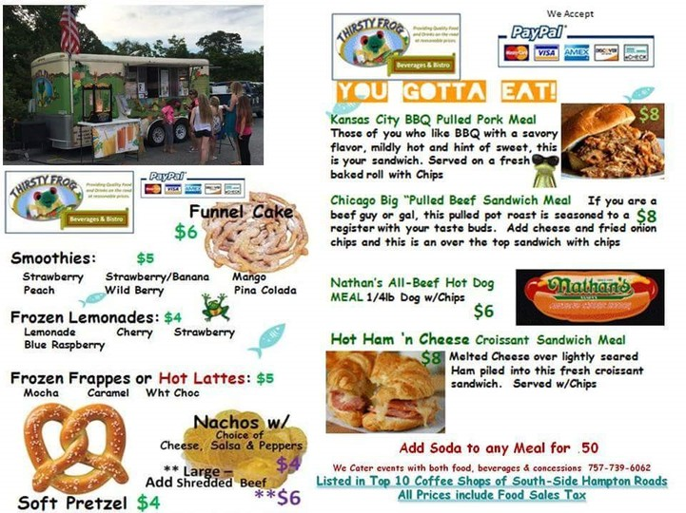

Judges
We would like to thank Jon Bescher and Leerie Jenkins for being our judges for this tournament.

Emergency –

The Cove – Center of Veterinary Expertise 6550 Hampton Roads Parkway #113 Suffolk, VA 23435 757-935-9111

Greenbrier Veterinary Emergency Center 110 Eden Way North Chesapeake, VA 23320 757-366-9000

Site Address

Franklin Southhampton County Fairgrounds 25374 New Market Road Courtland, VA 23851 If you have any questions, contact Lisa Daum at 252-339-8529 or hairierjumpjets@gmail.com .

