Welcome to the 2019 TURKEY TROT!!!!

Racing Format: This tournament is a two ring, one schedule tournament. Warm ups will be 2 minutes throughout the weekend to allow spacing between races. We will be using one race schedule for the two rings.

Tournament Scoring Format: All divisions racing 3/3, 4/4 or 5/5 format will earn one tournament point for each heat won, and two tournament points for winning the race. Regular 1, Open 1 and Multi 1 Divisions running 3/5 format: 2 points for winning a race; 1 point for tied
races for all races (3/5, 5/5 and 3/3 races). No tournament points will be given for tied heats.
One tournament point will be given to each team for tied races. Tournament placements are determined by adding up all accumulated points.

Tie Breakers:

1. Fastest time head to head
2. Fastest time in division (including combined‐division if applicable)
3. Tie‐breaker race: 2 of 3 heats

Venue Information: Franklin Southampton County Fairgrounds, 25374 New Market Road, Courtland, VA 23851. The building will be open until 9:00 pm Friday if you wish to drop off your flyball box. There will be no crating in the race building; however, crating is allowed in the smaller building and at any of the outside covered pavilions.

Camping: RVs are allowed on site for overnight parking. Please make sure that there is nothing for the neighbors to complain about! There will be a $25 per night fee for anyone staying the night in vehicles or RV’s. Someone from HJJ will be collecting the camping fee as you drive through the gate this year. If no one is there please find a HJJ member to check in.

Friday/Saturday Mat Time. We will be offering “mat time” Friday and Saturday evening, beginning at 6:00 pm. This is for any dog that would like to participate. You may start signing up at 4:30 pm. Cost will be $5/5 minutes. Please let us know if you need to rent the empty lane next to you or if you can utilize your mat time with a neighbor. Anyone not participating in the Turkey Dinner can start immediately after racing.

Racing Schedule

Friday
4:30 pm Mat Time Signup
6:00 pm Mat Time Starts
8:45 pm Mat Time Ends
9:00 pm Building Closes

Saturday
7:30 am Building opens Box and lane check
8:15 am Height dog measuring
8:45 am Captain’s meeting
9:00 am Racing Starts
5:00 pm Racing Ends (estimated)

Sunday
7:30 am Building opens
8:00 am Racing starts
1:00 pm Raffle Drawing
2:00 pm Racing Ends – Awards (estimated)

Food: J&K Style Grill will be serving lunch on Saturday only.
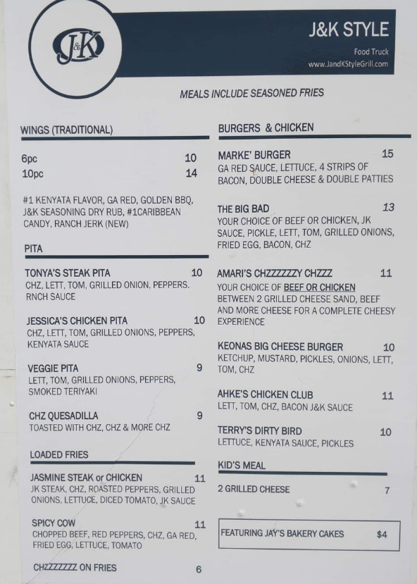

Pictures with Santa: New this year. Santa will be with us on Saturday after racing for pictures with Santa. Cost is $5.00 with proceeds being donated to one of our local shelters.

Massage and Bemer Treatments: Beth Agresta will be attending and offering massage for our two legged guests and Bemer treatments for two and four legged guests.

Judges: We would like to thank Jon Bescher, Leerie Jenkins, Chris Carr, and Amy Stewart for being our judges for this tournament. Line and Box Judges Worker Raffle - HJJ is a small team, so at times will need your help with line and box judge volunteers. Please consider sending your box loader to boxjudge the race after yours, if possible. Line and box judges will be given a raffle ticket for each race they judge. Every 1½ hours $10.00 will be raffled for the volunteer judges.
You must claim your prize or another ticket will be drawn at the end of the tournament until the prize is claimed. If you see an empty chair, please jump in and judge. HJJ club members and family members are not eligible to win.

Emergency – The Cove – Center of Veterinary Expertise 6550 Hampton Roads Parkway #113 Suffolk,
VA 23435 757-935-9111

Greenbrier Veterinary Emergency Center 110 Eden Way North Chesapeake, VA 23320
757-366-9000

Site Address Franklin Southhampton County Fairgrounds 25374 New Market Road Courtland, VA
23851

If you have any questions, contact Lisa Daum at 252-339-8529 or hairierjumpjets@gmail.com .

